**Introduction**

In today's digital age, it is essential for restaurants to have an online presence to attract and retain customers. One important aspect of this online presence is the ability for customers to make table reservations through the restaurant's website.

**Step 1: Determine the necessary fields**

The first step in creating a table booking form is to determine the necessary fields. There fields typically include the date and time, the number of guests and contact info such as name , phone no, email.

**Step 2: Create the form**

Once we determine the necessary fields, we can start our creating job. Using HTML and CSS we create this table.

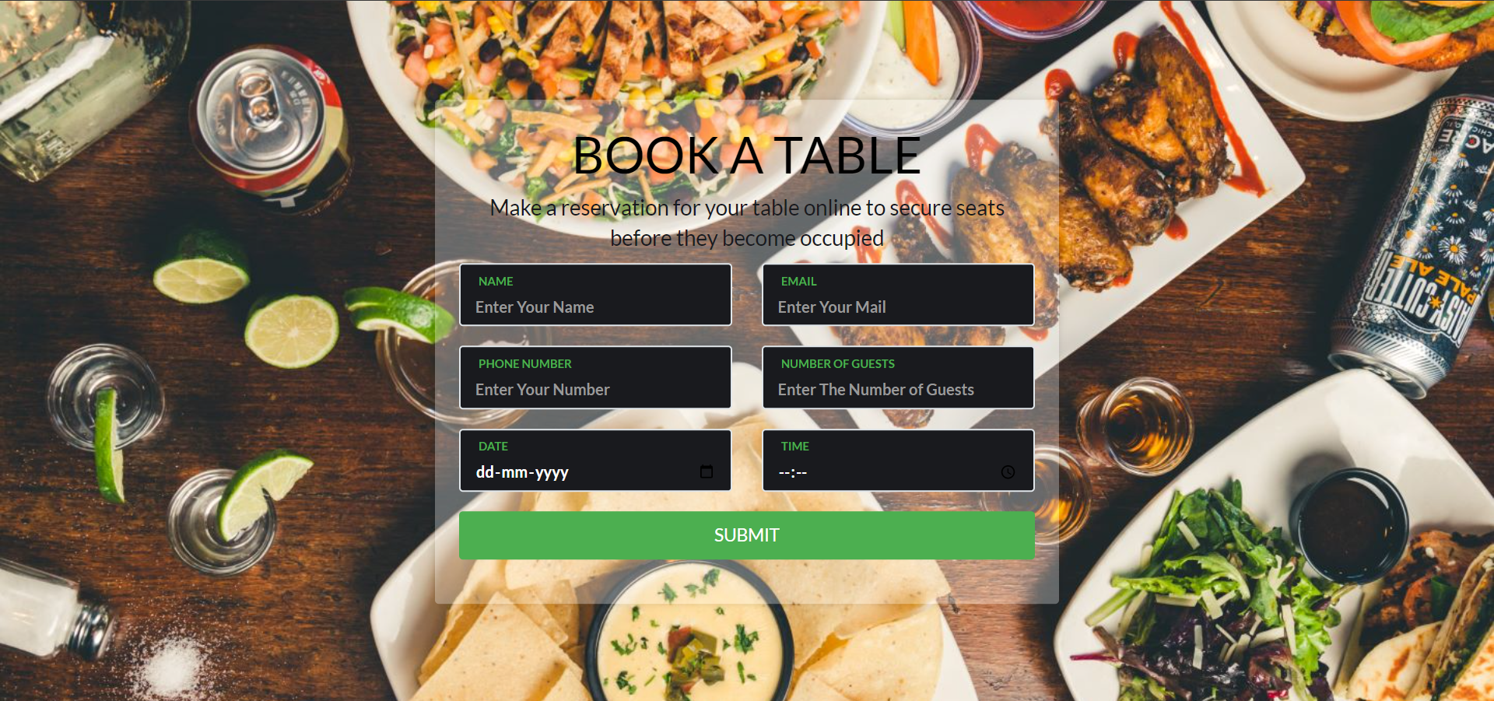

**Step 3: Add validation**

To ensure that customers enter valid information we can add some validation attributes to each field. For example you can require every fields and validate email address or phone no.

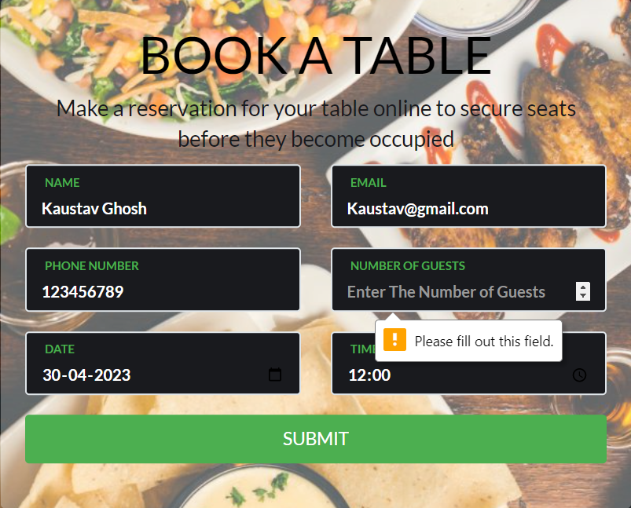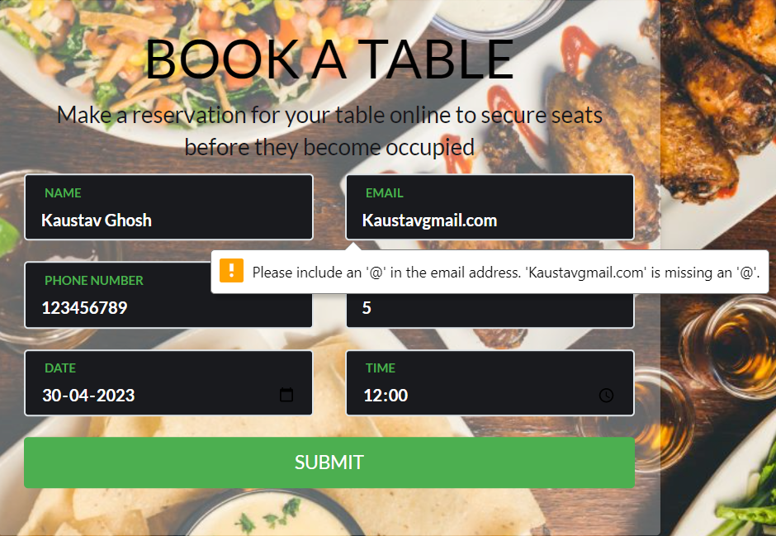

**Step 4: Responsive**

In today’s digital age we are using many kind of devices like computer, laptop, mobile, tab even we can use smart tv to access internet, So the website we creating must be accessible from every device. That’s mean websites should be responsive for every device.

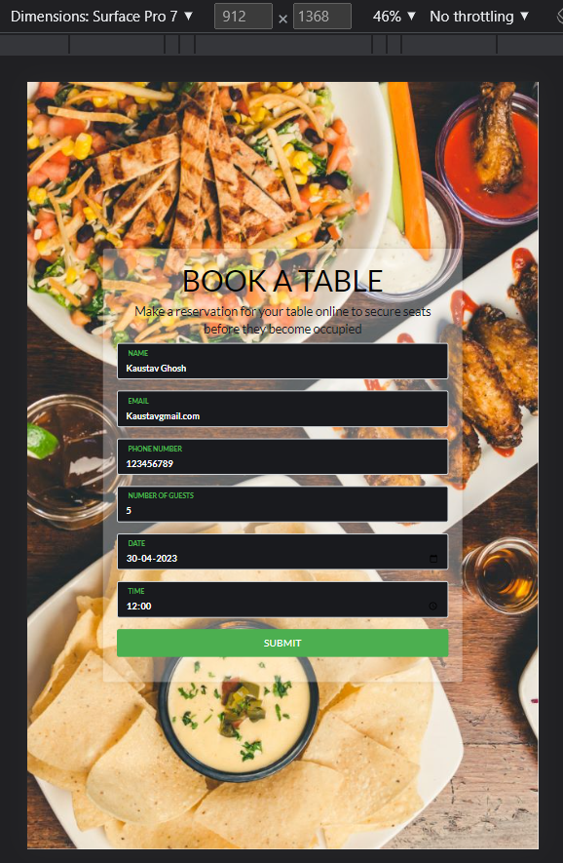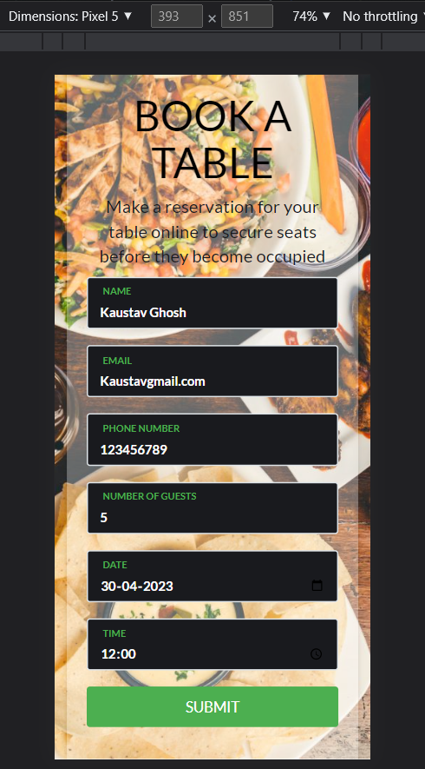

**Conclusion**

Creating a table booking form for a restaurant's website is a straightforward process that can greatly benefit both customers and management. By following these steps, you can create a user-friendly form that allows customers to easily reserve a table while also streamlining the reservation process for your restaurant's management team.